Friends of Selsdon Wood Newsletter November 2020
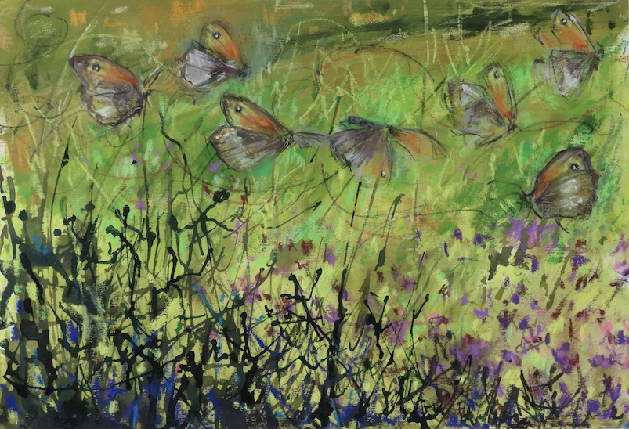
Beautiful Paintings of our wood – A collection of beautiful paintings like this one were done in our woodlands and fields last summer by Melanie Mascarenhas. She has given us permission to display them on our website Home page.
Some will be on display at an exhibition taking place from 28 October - 8 November at The Mall Galleries https://www.mallgalleries.org.uk/whats-on/exhibitions/natural-eye-2020
The three pieces on display there can be purchased via the Gallery, Email Melanie for further details. melaniemascarenhas1@gmail.com
Bee Friendly Road Verges? The Parks Survey run by the Council during August and September had over 2,300 replies – more than most online surveys. They found that 60% of respondents have discovered a new park during lockdown and 86% value their parks even more since lockdown – which shows the important role parks play in people’s wellbeing. Moreover, 88% want to see an increase in the biodiversity value of their park which links to the 96% who want to see more bee and butterfly friendly habitats across the borough.
This prompted the Council to ask residents to get involved in creating more bee friendly road verges in their streets, see the news link below for more details or if you would like to nominate your road to be a ‘wildlife friendly road’ by changing the mowing regime of their road verge to encourage more wild flowers, register your interest at biodiversity@croydon.gov.uk
https://news.croydon.gov.uk/building-bee-highways-and-butterfly-corridors-and-how-you-can-play-your-part/
FSW Work in the Wood - As reported last month, all scheduled workdays this year have been cancelled due to the corona virus. However the Workdays team continue to work in small groups in a Covid-secure way or individually at times convenient to them. Tasks completed this month have been the replacement of some signs that had been taken down before the widening of the rides at Beech Grove, Court Wood Grove and Langford’s Way and the clearance of a few falls including a huge Birch trunk between Greenhill Way and David’s Crook. Full reports of their work are given on the Workdays page of the website http://www.friendsofselsdonwood.co.uk/workdays.php .
Linden Glade Pool - There was a letter in last month’s Selsdon Gazette about the sorry state of the Linden Glade pool. You may remember that between 2016 and 2018 the FSW put a lot of work into restoring the pool which had cracked. It was cleared out and resealed and the water supply was restored. However the cracks have recurred and are likely to continue to do so as the underlying tree roots are constantly pushing up against the concrete liner. It seems that even a total replacement in this position would suffer from the same problems so FSW are currently in negotiation with the Council about the production of a completely new pool, perhaps in or close to Linden Glade or possibly in an entirely different location. We will keep you posted about the progress of this project.
Sightings - The Sightings page of our website http://www.friendsofselsdonwood.co.uk/sightings.php is updated almost daily and at this time of year most of the photos are of fungi. So far this year 92 different species have been photographed. Why not join in by sending us your photos of any fungi you spot in our woods. Perhaps we will soon manage to push the numbers seen up to 100. Of course, reports of other sightings are also welcome - our white squirrels have not been spotted for some time.
The FSW Calendar 2021 is available for a donation of £5 - To get your copy phone 020-8657-0423 or email govierh@gmail.com or contact us on the addresses given in the footer below - See below for a reminder of some of the beautiful photographs included in next year’s calendar
FSW Calendar 2021  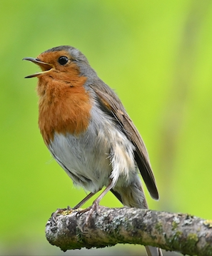  Cover Photo – Robin by Jack Branscombe | January  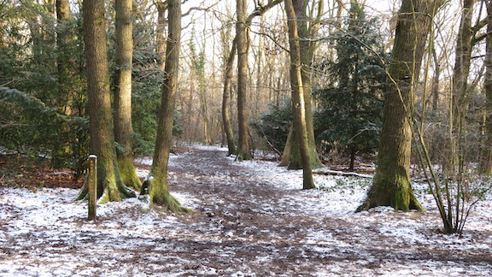  Just Like a Painting by John Zareba | February  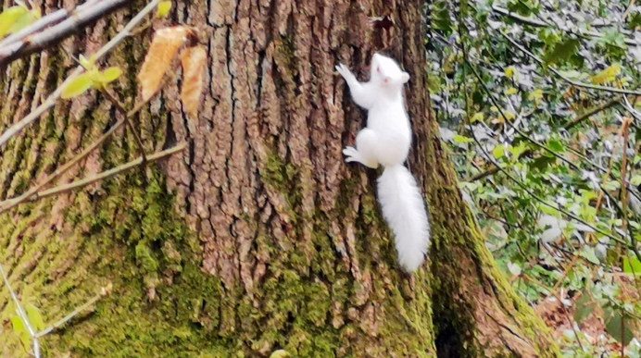  White Squirrel by Josie Searle
 | March  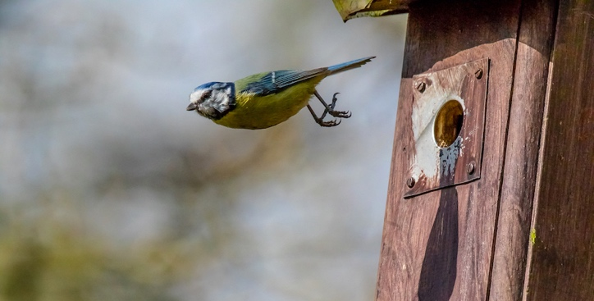  Bullet Drop by Steven Budd | May  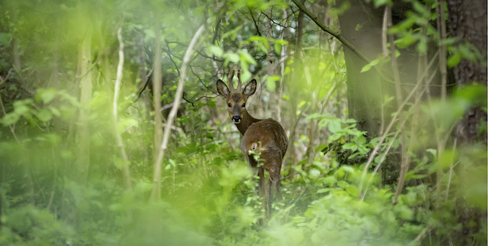  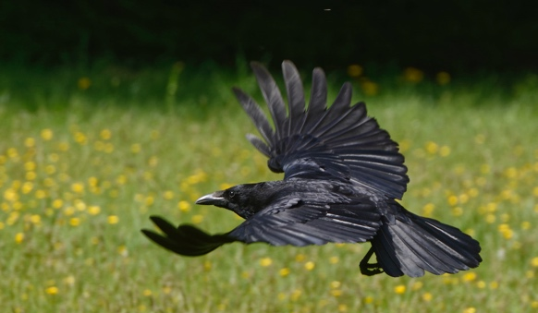  Deer by Ian Schofield
July  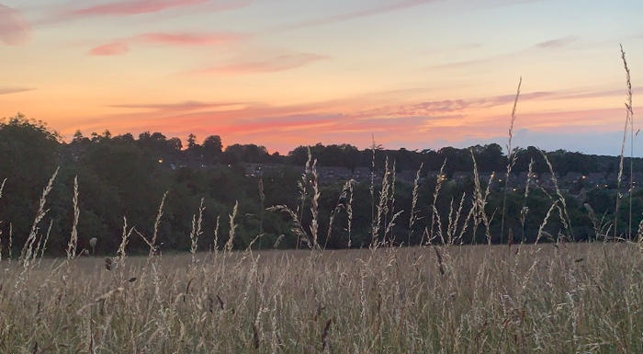  Bat Walk Sunset by Linda Morris | September  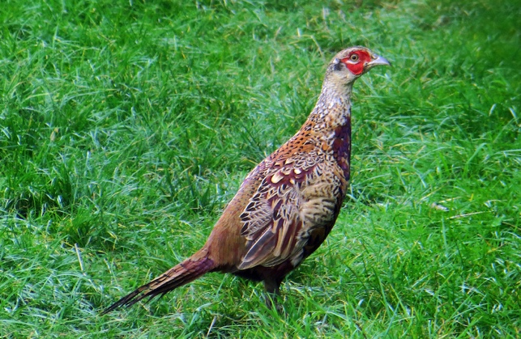  Juvenile Cock Pheasant by Tony Flecchia | December  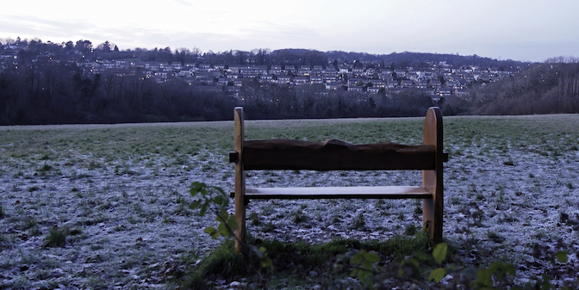  The Vale from the Wood by David Pinkney

